# Deployment Settings

NOTE: After deployment, you have to login manually with user [cs@portalqa.com](mailto:cs@portalqa.com) using password Testing123 and then change the password to Testing321.

(DON’T THINK WE HAVE TO DO THIS ANYMORE)

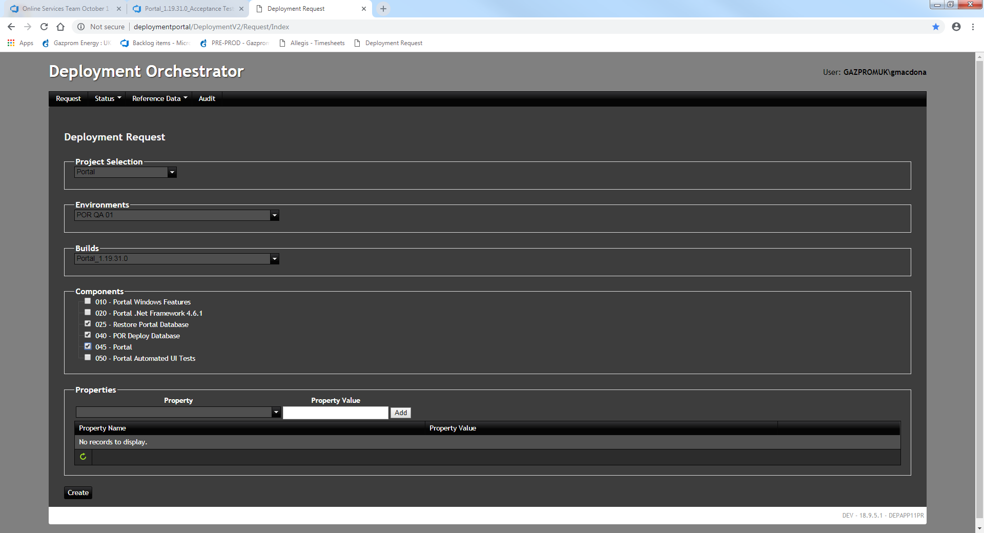

Click on Create

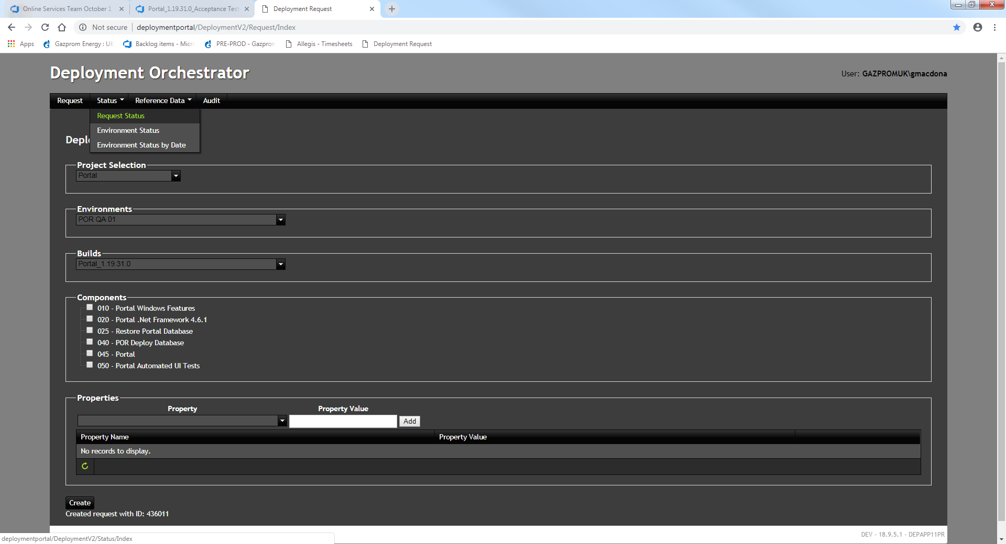

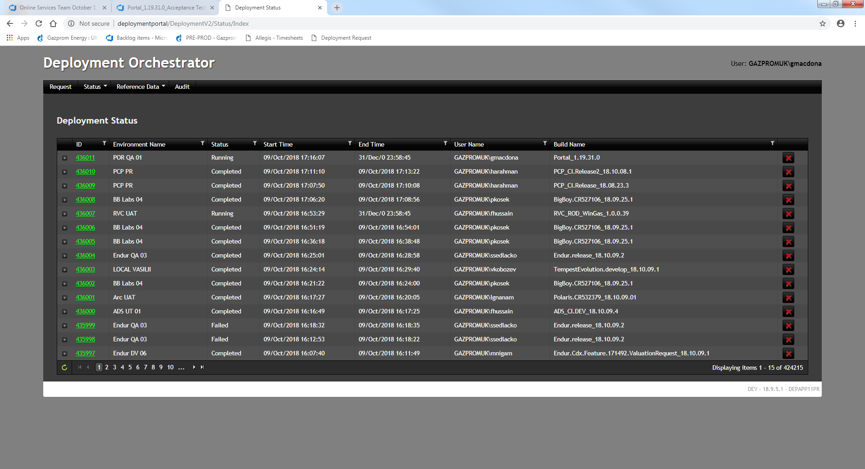

Wait for status of your job to be completed (click on refresh every so often)